EGEN CHALLENGE LEVEL 2 DOCUMENTATION

**1)create** – this is the API that will consume data from the sensor emulator

For testing purpose passing Json object from PostMan and its working fine.

Below is the screenshot.

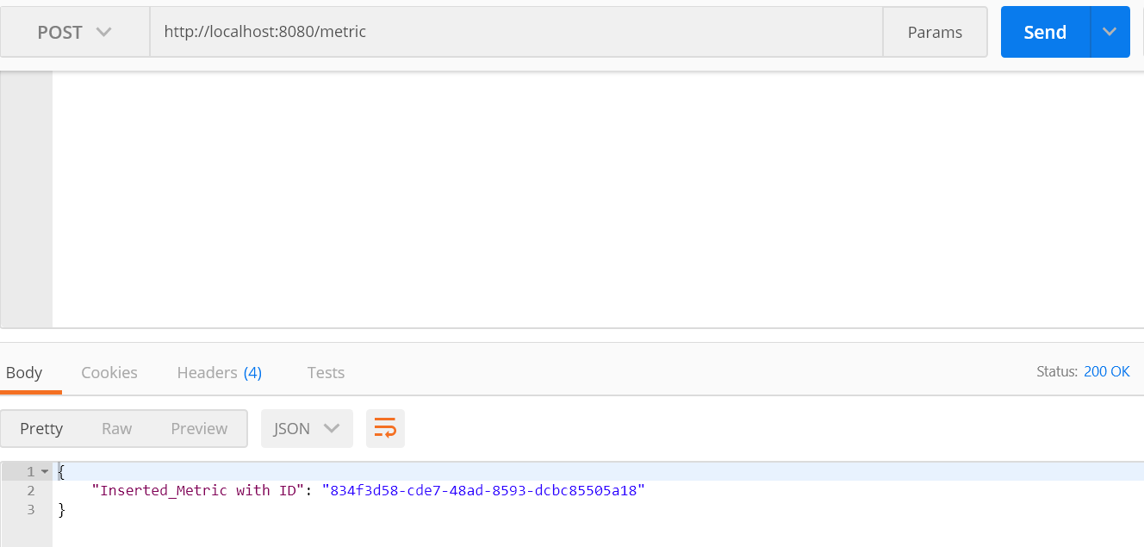

Mongo Db:

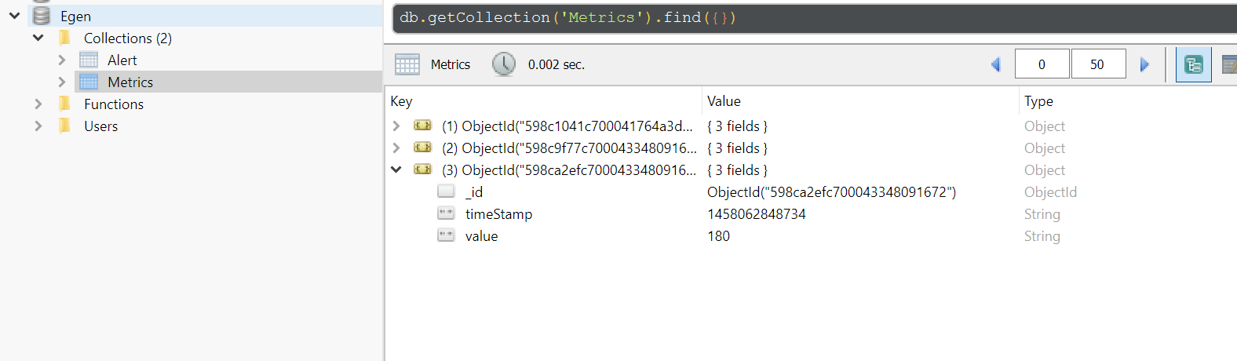

**2) read** – reads all the metrics stored in your database

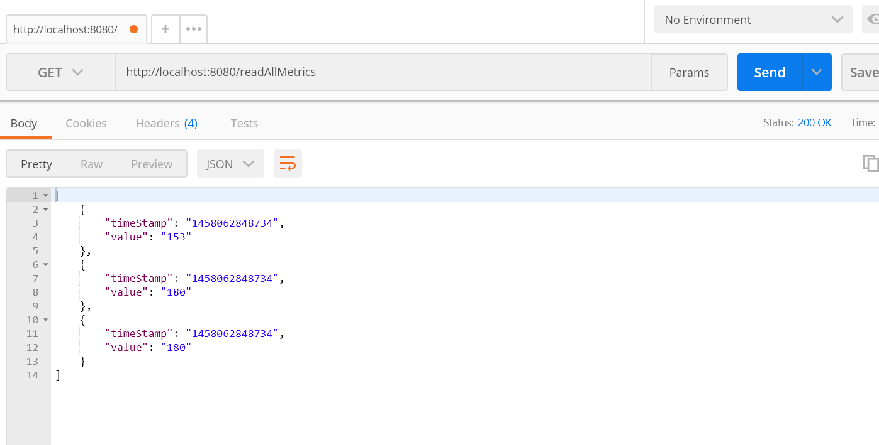

**read** – reads all alerts that are stored in the database: similar way as Above.

**Rules:**

**Created a single rule to check 10% reduced or 10% increased weight.**

